All Saints Halifax - 10:30 Communion Service with children’s groups

My name is _________________.
On Sunday morning, I am going to All Saints Church for the 10:30am service | ​​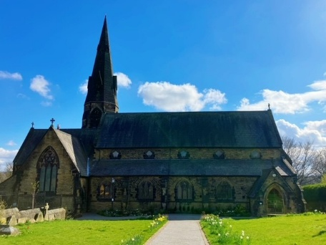​
Someone will say “hello” to me when I come into the building. They are being friendly. | 
Inside the church will look like this. I can sit on any empty seat, or get a bean bag to sit on the floor | ​​ ​ 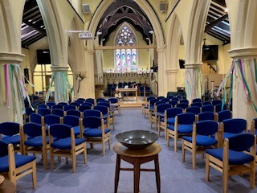
There will be a visual timetable on the screen for me to look at and on the wall. This will help me to know what is happening and what is next. | 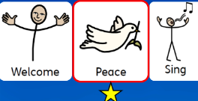
During the service, we will sing songs. I can stand up or sit down to sing. It is OK to dance, move around or play the instruments that will be at the front of the church. | 
The leader will help us say prayers. Sometimes I need to sit quietly to pray. Sometimes, I will be told how I can join in. I can say “amen” at the end if I agree with them. | 
I will have a chance to go a group, with others my age. Groups are upstairs in church. I can find out what’s happening in the group by asking the group leader before the service. I can stay in the main worship space downstairs if I’d prefer. | 
If I stay downstairs we will hear a reading from the Bible. I will be able to see the Bible reading on the screen. There might be pictures or a video for me to look at. I need to listen to the reading. | 
The preacher will tell us what the Bible reading means. I need to listen to what they are saying. | 
The vicar will say a prayer telling the story of God and his people. We’ll use bread and wine to remember and celebrate Jesus’ story. I’ll have the opportunity to come to the front and have a piece of wine and bread, or have a blessing, where the vicar will prayer that God will be with me. I can stay in my seat if I prefer. | 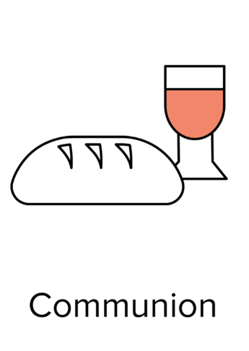
After the service, I can have a drink and a biscuit and talk to people. | ​​​

